

SUREKEY EXAMINATIONS BOARD

**PRIMARY FOUR QUALITY CHECK ONE EXAMINATION**

2024

SOCIAL STUDIES WITH RELIGIOUS EDUCATION

***Time Allowed: 2 hours 15 minutes***

**School Admission No. Personal No.**

**Pupil’s Name:** ……………………………………..………………………..………………………..

**Pupil’s Signature:** …………………………………………………………..……………………….

**School Name:** …………………………………………………………………………………………..

**District Name:** …………………………………………………………………………………………

**Read the following instructions carefully:**

**FOR EXAMINERS’**

**USE ONLY**

**Qn. No. MARKS EXR’S**

**NO.**

1 – 10

11 − 20

21 – 30

31 – 40

41 – 43

44 – 46

47 – 49

50 – 52

53 – 55

**TOTAL**

1. Do not forget to write your **school** or

**district name** on the paper.

1. This paper has two sections: **A** and **B**. Section **A** has **40** questions and section **B** has **15** questions. The paper has **12** printed

pages.

1. Answer **all** questions. **All** working for both sections **A** and **B** must be shown

in the spaces provided.

1. **All** answers **must** be written using a **blue**

or **black** ball point pen or ink. Any work

written in pencil will **not** be marked.

1. Unnecessary **changes** in your work and handwriting that cannot be read

easily may lead to **loss of marks**.

1. Do not fill anything in the table indicated:

**“For Examiners’ use only”** and boxes

inside the question paper.

***©*** *2024 Surekey Examinations Board 0700758668* **Turn Over**

**SECTION A: 40 MARKS**

Questions **1** to **40** carry **one mark** each

1. Give any **one** economic activity carried out in swamps.

………………………………………………………………….………………………………….….…

1. State any **one** way in which wind is important to sailors.

…………………………………………………………………………………………………….……..

1. How do we call the animals which live on their own in natural environment?

…………………………………………………….……………………………………………………..

1. Give any **one** raw material for making crafts.

………………………………………………………………….……………………………….…….…

1. Why is a salon an important place in your community?

……………………………………………………………………………………………………………

…………………………………………………………………………………………………………..

1. Name the object whose map is drawn below.

……………………………………………….……………………………………………………………

1. Give any **one** cause of insecurity in our communities.

………………………………………………………………………………………………………......

1. Mention any **one** cause of accidents on busy roads in your district.

…………………………………………………………………………………………………………….

1. In which **one** way are school holidays important to children?

……………………………………………………………………………..………………………….…

…………………………………………………………………………………………………………..

1. Mention any **one** source of water in the environment.

………………………………………………………………………………………………..…..….…

**2**

1. Why is a television not regarded as a basic need of man?

………………..…………………………………………………………………….……………………

1. Name the type of houses built using sand and cement.

……………………………………………………………………………..…………………………….

1. Who is a black smith?

…………………………………………………………………………………………………..………

…………………………………………………………………………………………………………..

1. Give any **one** reason why people should protect the forests from being

destroyed.

…………………………………………………………………………………………….…………….

1. Write any **one** type of transport which does not provide door-door services.

……………………………………………………………………………………………………………

1. Mention any **one** tribe in Uganda which practices circumcision.

……………………………………………………………………………………………………………

1. Give any **one** reason why school children must put school uniform.

……………………………………….…………………………………….…………………………..

1. State any **one** way through which father is an important person in a family.

……………………………………………………..……………………………………………………

1. Write the compass direction indicated by letter **K** on the diagram below.

N

**K**

…………………………………………………………………………………………………………

1. Name the traditional occupation of the Baganda.

…………………………………………………………………………………………………………

1. How are market vendors important in our communities?

…………………………………………………………………………………………………………

**3 Turn Over**

1. Apart from school children, mention **one** other group of people who put on

a uniform at their work.

………………………………………………………………………………………………….…..……

1. Give **one** factor which prevents some people from meeting their needs.

………………………………………………………………………………………………….…………

1. Why is it easier to understand a picture of an object than its map?

………………………………………………………………………………………………..………….

1. Write any **one** category of people who use a compass to do their work.

……………………………………………………………………………………….…………………..

1. Mention any **one** type of weather.

…………………………………………………………………………………….……………………..

1. Give any **one** human made source of water in our localities.

……………………………………………………………………………………….……………………

1. State any **one** reason why some people in your community rear domestic

animals.

……………………………………………………………….……………………………………………

Use the item below to answer the questions **29** and **30**.

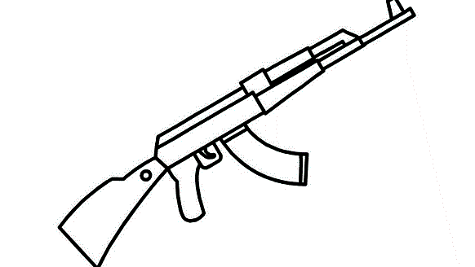

1. Write any **one** group of people who use the item above while at their work.

………………………………………………………………………………………….………………..

1. Apart from the item above, mention **one** other item used to keep security.

…………………………………………………………………………………………………………….

1. Name the member of the Local Council One (LC1) committee who is in

charge of children’s affairs.

…………………………………………………………………………………………………………….

**4**

1. Mention any **one** modern mean of communication.

…………………………………………………………………………………………………………….

1. State any **one** way in which electricity is important in our homes.

………………………………………….…………………………………………………………………

1. Write any **one** product we get from sugarcane.

……………………………………………………………………………………………………….……

For each of the questions **35** to **40**, answer **Either** the Christian **OR** Islamic questions but **not** both. No **marks** will be awarded to a candidate who attempts both alternatives in **a particular number**.

1. **EITHER:**

Mention any **one** fruit of the holy spirit.

…………………………………………………………………………………………………………….

**OR:**

Mention any **one** pillar of Islamic faith.

………………………………………………………………………………………………….………..

1. **EITHER:**

Name the God’s servant who was swallowed by a big fish due to his

disobedience.

……………………………………………………………………………………………….…………..

**OR:**

Name the Allah’s servant who was swallowed by a big fish due to his

disobedience.

……………………………………………………………………………………………….…………..

1. **EITHER:**

Write any **one** thing a Christian child should thank God for**.**

…………………………………………………………………………………………………………...

**OR:**

Write any **one** thing a Muslim child should thank Allah for.

……………………………………………………………………………………………………………

**5 Turn Over**

1. **EITHER:**

On which mountain did Noah’s ark rest after the end of floods.

……………………………………………………………………………………………………………

**OR:**

On which mountain did prophet Nuh’s ark rest after the end of floods.

……………………………………………………………………………………………..……………

1. **FOR BOTH**

Write any **one** way you can manage sorrowful moments in your life.

……………………………………………………………………………………………………………

1. **EITHER**

On which mountain did Moses receive the Ten commandments?

……………………………………………………………………………………………………………

**OR**

On which mountain did prophet Mohammadi receive the holy Qur’an?

…………………………………………………………………………………………………….………

**SECTION B: 60 MARKS**

Questions **41** to **55** carry **four** marks each.

1. (a) Write any **two** examples of children’s rights.
2. …………………………………………………………………………………………
3. ………………………………………………………………………………………….

(b) State any **one** cause of child abuse in our community.

………………………………………………………………………………………………….

(c) Give **one** reason why it is bad for children to walk alone at night.

…………………………………………………………………………………………………..

1. (a) Write any **two** recreation activities commonly done by school children.
2. ……………………………………………………………………..……………………
3. ……………………………………………………………………………………………
4. State any **two** ways how recreation activities benefit school children.
5. …………………………………………………………………………………………..
6. …………………………………………………………………………………………..

**6**

1. Part **A** of the table below shows some tribes in Uganda and Part **B** has the

title of the traditional leaders of those tribes but in wrong order.

|  |  |
| --- | --- |
| **Part A:** Tribe | **Part B:** Traditional Leader |
| 1. Basoga 2. Batooro 3. Acholi 4. Bakonjo | Riwot  Omusinga  Omukama  Kyabazinga. |

Match the tribes below with the title of their traditional leader correctly.

1. Basoga ………………………………………………………………………………….
2. Batooro ………………………………………………………………………………….
3. Acholi …………………………………………………………………………………
4. Bakonjo …………………………………………………………………………………

1. (a) Writeany **one** place where people of your community keep their

money safely.

……………………………………………………………………………………………………

(b) State any **one** way how people get money.

………………………………………………………………………………………………..….

(c) State any **two** ways in which money is important to people in

your community?

1. …………………………….………………….……….…………………………………
2. …………………………………………………………….……………………………..
3. (a) Give a difference between food crops and cash crops.

……………………………………………………………………………………………………

……………………………………………………………………………………………………

(b) Mention any **two** examples of traditional cash crops.

(i) ……………………………………………………………………………………….….

(ii) …….……………………………………………………………………………………..

(c) Give **one** reason why people should grow more food crops.

……………………………………………………………………………………………………

**7 Turn Over**

1. 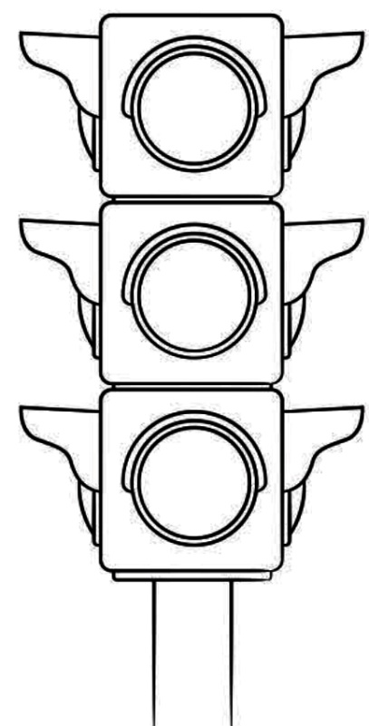The diagram below shows a road sign. Use it to answer the questions that follow.

**A**

**B**

**C**

(a) Identify the road sign drawn above.

……………………….…………………………………………………………………………

(b) Name the colours of the road sign indicated by **A** and **B**.

1. **A** ……………………………………………………………….………………….
2. **B**  …………………………………………………………………………………..

(c) What does the colour **C** tell the vehicles driver to do?

…………………..……………………………………….…………………………………….

1. (a) What is a community?

……..………………………………………………………………….…………………….…

.………………………………………………………………………………………….……..

1. How do we call the activities that can bring community members together?

……….…………………….……………………………………………………………………

(c) Mention any **two** examples of activities that bring people together

in your community.

1. …………………………………………………………………………………………..
2. …………………………………………………………………………………………..

**8**

1. Write the element of a good map which plays each of the roles below

on a map reader.

1. Showing direction of places on a map.

……………………………………………………………………………………………………

1. Interpreting symbols used on a map.

……………………………………………………………………………………………………

1. Used to calculate the actual ground distance on a map.

……………………………………………………………………………………………………

1. Telling what the map is all about.

……………………………………………………………………………………………………

1. 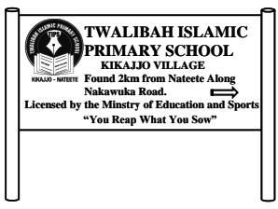Study the school symbol below and use it to answer the questions that follow.
2. Identify the school symbol drawn above.

……………………………………………………………………………………………………

1. In which village is the school on the above symbol located?

……………………………………………………………………………………………………

1. Write **one** important information found on the above school symbol.

……………………………………………………………………………………………………

1. Apart from the above, mention any **one** other symbol of a school.

……………………………………………………………………………………………………

**9 Turn Over**

1. (a) What name is given to a place where weather conditions are studied

and recorded?

…………………………………………………………………………………………………..

1. Mention the weather condition which forces people to put on

light clothes.

……………………………………………………….………………………….………………

1. State any **two** dangers caused by weather changes in the

environment.

1. ……………………..………..…………………………………………………………..
2. ………………………………….…………………………………………………………

For each of the questions **51** to **55**, answer **EITHER** the Christian **OR** Islamic questions but **not** both. **No mark** will be awarded to a candidate who attempts

both alternatives in **a particular number**.

1. **EITHER:**
2. What term refers to the invisible divine grace of God.

…………………………………………………………………………………………………..

1. Write any **two** items during baptism in the church.
2. ……..…..………………………………………………………………………………..
3. ……………………………………………………………………………………………
4. Mention any **one** Christian religious leader who baptizes people in

the church

….….……………………………………………………………………………………………

**OR:**

1. What term refers to the cleaning of one’s body parts using clean

dust or sand?

…………………………………………………………………………………………………

1. Write down any **two** body parts a Muslim must clean during ablution.
2. …………………………………………………………………………………………..
3. …………………………………………………………………………………………..
4. Give **one** condition under which a Muslim may use clean dust or

sand for ablution.

……………..…..………………………………………………………………………………

**10**

1. **EITHER:**
2. What is a prayer according to Christian teaching.

…………………………………………………………..…………………………………..…

1. Give any **two** reasons why Christian pray.
2. …………………………………….…………………………………..………………
3. ………………………………………………………………………..……………….
4. Write **one** way how you prepare for church service.

…………………………………………………………………………………………………..

**OR:**

1. What are optional (sunnah) prayers?

………………..……………………………………………..…………..……………………

………………….………………………………………………………………………………

1. Give any **two** reasons why Muslims pray.
2. …………………………………………………….…………………………………….
3. …………………………………………………………………………………………..
4. Write **one** way how you prepare for Jumah prayers.

………………………………………………………………………………….……………..

1. **FOR BOTH:**
2. Give any **two** examples of God/Allah given abilities.
3. …………………………………………..………………………………………………
4. …………………………………………………………………………………………..
5. State any **two** ways you can help your friends in need at school.
6. …………………………………………………………..…….…………………………
7. ……………………………………………………………………………………………
8. **EITHER:**
9. Which holy day marks the beginning of Lent in Christianity?

…………………………………………………………………………………………………

1. Write any **two** good things a Christian expected to do during the

lent.

1. …………………………………………………………………………….……………
2. ………………………………………………………………………………………….

**11 Turn Over**

1. Give any **one** reason why it is important for Christians to fast.

……………………………………………………………………………….………………..

**OR:**

1. Which holy day marks the end of Ramadhan in Islam?

…….…………………………………………………………………………………………..

1. Write any **two** good things a Muslim is expected to do during

Ramadhan.

1. ………………………………..……………….…………………………………………
2. …………………………………….……………………………………………………..
3. Give any **one** reason why it is important for qualified Muslims to fast.

…….……….………………………………………………………………………………….

1. **EITHER:**

Match God’s servants in list **B** with what they are remembered for in list **G**

using a pen.

**List B**  **List G**

1. Moses He was a tax collector
2. Abraham His name means rock
3. Simon Peter Led the Israelites out of Egypt
4. Mathew He had very strong faith

**OR**

Match the Prophets in List **B** with the divine books they received in

List **G** using a pen.

**List B List G**

1. Muhammad Tauret
2. Dauda Injir
3. Musa Qur’an
4. Issa Zabur

**12 END**